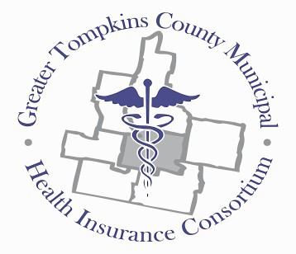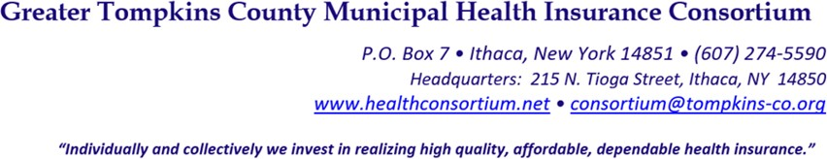

RESOLUTION NO. 038–2022 – AUTHORIZING INFORMATION TECHNOLOGY SERVICES
AGREEMENT WITH TOMPKINS COUNTY – JANUARY 1, 2023 THRU DECEMBER 31, 2023

MOVED by Mr. Salton, seconded by Mr. Hall. The resolution was unanimously adopted by voice vote of members present, visibly seen members via remote Satellite locations, and locations due to extraordinary circumstances.

WHEREAS, the Tompkins County Information Technology Services Department (ITS) has provided technical support to the Consortium since it began operations in 2011, and

WHEREAS, the Consortium wishes to continue its contract arrangement with the Tompkins County Information Technology Services Department that was formalized in 2020, and

WHEREAS, the 2023 Memorandum of Agreement, between the Greater Tompkins County Municipal Health Insurance Consortium and the Tompkins County Information Technology Services Department (ITS) for the provision of technology services provided to the Consortium, including support in compliance with 23 NYCRR 500, now therefore be it

RESOLVED, on recommendation of the Audit and Finance Committee, That the Board of Directors approves an agreement with Tompkins County Information Technology Services for 2023 for ITS support provided to the Consortium from January 1, 2023 thru December 31, 2023, and

RESOLVED, further, That the Executive Director is hereby authorized to execute this contract on behalf of the Consortium.

**************

GTCMHIC ) ss:
COUNTY OF TOMPKINS )
STATE OF NEW YORK )

I hereby certify that the foregoing is a true and correct transcript of a resolution adopted by the Greater Tompkins County Municipal Health Insurance Consortium Executive Committee on behalf of the Board of Directors on December 7, 2022.
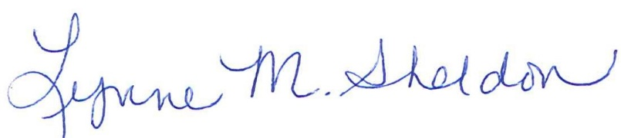

______________________________________
Lynne Sheldon, Clerk of the GTCMHIC Board

STATE OF NEW YORK )
) ss:
COUNTY OF TOMPKINS )

I hereby certify that the foregoing is a true and correct transcript of a resolution adopted by the Greater Tompkins County Municipal Health Insurance Consortium Executive Committee on behalf of the Board of Directors on December 15, 2021.
