RESOLUTION 035-2022- EXTENDING CONTRACT FOR ACTUARIAL SERVICES – ARMORY ASSOCIATES- FISCAL YEAR 2022

MOVED by Mr. Snow, seconded by Ms. DeVoe. The resolution was unanimously adopted by voice vote of members present, visibly seen members via remote Satellite locations, and locations due to extraordinary circumstances.

WHEREAS, the Greater Tompkins County Health Insurance Consortium issued a Request for Proposals for Actuarial Services on January 4, 2016 and awarded a contract to Armory Associates of Syracuse, and

WHEREAS, in 2019 Armory Associates presented a three-year proposal for fiscal years 2020, 2021, and 2022, and

WHEREAS, the Consortium wishes to continue its relationship with Armory Associates under the terms outlined in the revised agreement for actuarial services, now therefore be it

RESOLVED, on recommendation of the Audit and Finance Committee, That the Executive Committee, on behalf of the Board of Directors hereby extends its contract with Armory Associates for the third year of the current agreement, and

RESOLVED, further, That the Executive Director is hereby authorized to execute this contract on behalf of the Consortium.

*********

STATE OF NEW YORK )
GTCMHIC ) ss:
COUNTY OF TOMPKINS )

I hereby certify that the foregoing is a true and correct transcript of a resolution adopted by the Greater Tompkins County Municipal Health Insurance Consortium Executive Committee on behalf of the Board of Directors on December 7, 2022.
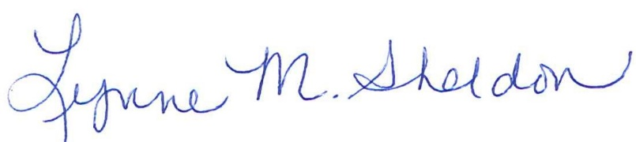

______________________________________
Lynne Sheldon, Clerk of the GTCMHIC Board

