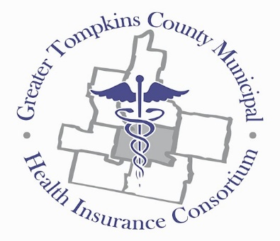
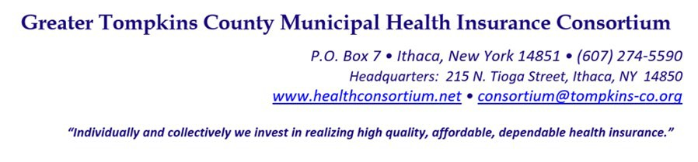

RESOLUTION NO. 013– 2022 – CLARIFICATION REGARDING PARTICIPANT MEDICARE-
AGED RETIREES IN RELATION TO MUNICIPAL COOPERATIVE AGREEMENT (MCA) REQUIREMENT

WHEREAS, Section A (5.) of the 2022 Amendment to the Municipal Cooperative Agreement states that “ Participation in the Medical Plan(s) by some, but not all, collective bargaining units or employee groups of a Participant shall not be permitted without a Board approved waiver”, and

WHEREAS, the Consortium continues to support having all collective bargaining units or employee groups in the Consortium risk pool to maintain stabilized premium rates and prevent adverse risk selection, and

WHEREAS, the Consortium’s has deemed the term “employee groups” to include active employees, COBRA continuation of coverage members, non-Medicare-aged retirees, and Medicare-aged retirees, and

WHEREAS, there have been some exceptions made, upon entrance, to allow Medicare- aged retirees of new Participants with fully-insured Medicare Advantage Plans to remain with said coverage, and

WHEREAS, the Consortium does not currently offer a Medicare Advantage Plan or Plans,
and

WHEREAS, several Participants are reviewing cost-effective options for their Medicare- aged retiree population, including moving from current Consortium coverage to fully insured Medicare Advantage plans with other carriers, and

WHEREAS, the Consortium believes that offering a Medicare Supplement Plan is an excellent option for Medicare eligible retirees; however, due to federal subsidies currently available to fully-insured plans the Consortium’s Medicare Supplement Plan is unable to compete with the lower costs of some Medicare Advantage Plans, and

WHEREAS, although the Consortium cannot set up a Medicare Advantage program within the fund, the Consortium can provide a convenient, pass-through option as is done with other ancillary benefits offered through the Consortium, now therefore be it

RESOLVED, That the Consortium, on behalf of the Board of Directors, will hereby enforce That Section A (5) “Participation in the Medical Plan(s) by some, but not all, collective bargaining units or employee groups of a Participant shall not be permitted without a Board approved waiver” will remain in force for all active and retired employee groups of each Participant,

RESOLVED, further, That any Participant selecting to withdraw an employee group shall request such waiver prior to September 1st of each year for consideration by September 30th or for new Participants as part of the application process.

RESOLUTION NO. 013– 2022 –CLARIFICATION REGARDING PARTICIPANT MEDICARE-
AGED RETIREES IN RELATION TO MUNICIPAL COOPERATIVE AGREEMENT (MCA) REQUIREMENT

RESOLVED, further, That the Consortium will secure an approved vendor by October 1, 2022 to provide a fully insured Medicare Advantage product to act as a pass through as a Medicare- aged retiree plan option commencing January 1, 2023 for Participants of the Consortium,

RESOLVED, further, That the Consortium will review annually charging a risk assessment fee to any Participant using a fully insured Medicare Advantage Plan product purchased from a source other than the Consortium.

RESOLVED, further, That any Participant currently enrolled in a fully insured Medicare Advantage Plan, not offered through the Consortium, at the time when this resolution is approved, will be grandfathered in as a Board approved waiver effective July 1, 2022, provided the Consortium has secured a similar product to offer to all Participants effective on January 1, 2023, this waiver will expire on December 31, 2024 and the Participant will be required to move to the Consortium Medicare Advantage Plan on a pass-through basis or be subjected to a risk assessment fee.

RESOLVED, further, That all Participants requesting a waiver to provide a fully insured Medicare Advantage Plan to their eligible employee groups on/or after January 1, 2023 will be required to use the Consortium secured Medicare Advantage Plan product.
* * * * * * * * *

STATE OF NEW YORK )
GTCMHIC ) ss:
COUNTY OF TOMPKINS )

I hereby certify that the foregoing is a true and correct transcript of a resolution adopted by the Greater Tompkins County Municipal Health Insurance Consortium Executive Committee on behalf of the Board of Directors on August 3, 2022.

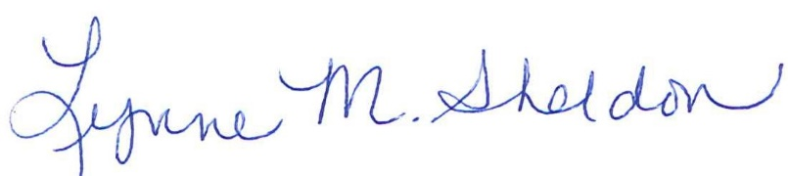

______________________________________
Lynne Sheldon, Clerk of the GTCMHIC Board

