**Memorandum**

**To: New York State Assembly**

**Insurance Committee**

**From: Judy Drake, Chairperson**

**Greater Tompkins County Municipal Health Insurance Consortium**

**Date: October 23, 2019**

**Subject: Development of Article 47 Municipal Cooperative Health Benefits Plan**

**Dear Esteemed Committee Members:**

On behalf of the Greater Tompkins County Municipal Health Insurance Consortium (“GTCMHIC”), we want to thank the esteemed members of the New York State Assembly Insurance Committee for this opportunity to share our story. In addition, we are appreciative of the Committee’s desire to receive insight into the development of a New York State Insurance Law Article 47 Municipal Cooperative Health Benefits Plan (“Article 47 Plan”) and some of the unique challenges facing municipal corporations who would like to follow our Consortium’s successful model of operation.

It is our hope that this memorandum will provide you with some perspective on how the GTCMHIC was developed and some of the challenges faced in the beginning. In addition, we hope to provide you with some perspective on some of the challenges we are facing as we head into our 10th year of operation.

***Consortium Development***

The initial work to develop the GTCMHIC began in 2007 as an idea developed through the Tompkins County Council of Governments (“TCCOG”). This development process was assisted early on when the County of Tompkins was awarded a New York State Shared Municipal Services Incentive Grant by the New York State Department of State.

In 2009, the development of the Consortium picked up speed with the signing of a New York State General Municipal Law Article 5-G Agreement. This Agreement signaled the commitment amongst the Municipal Corporations in Tompkins County who were interested in forming the GTCMHIC.

As part of the Consortium development process, the Steering Committee studied the unique challenges associated with bringing a number of Municipal Corporations together which had vastly different characteristics from employee counts, to overall budgets, and to the types of health insurance offered. In the end, the Committee looked at three (3) options for developing a Consortium for health insurance:

1. Bringing the municipalities together to purchase health insurance jointly either through the County of Tompkins or as a New York State General Municipal Law Article 5-G purchasing group. However, as we learned, if the Consortium purchased insurance on an experience-rated basis (e.g., through a minimum premium agreement), the small employers (at that time those with less than 50 employees) would be not be able to participate as they are required to be community-rated. It should be noted that this type of plan has been used quite successfully by School District and BOCES Consortiums around the State for more than 30-years.
2. Developing the Consortium as a New York State Insurance Law Article 44 Trust. The main issues that made this option not appealing to the Committee were the number of collective bargaining groups and the lack of representation that each Municipal Corporation would have in the decision-making process. Additionally, several municipalities did not have collective bargaining units representing their employees. Ultimately, the Municipal Corporations believed that they were responsible for the overwhelming majority of the premium cost and that the governance model should reflect this fact. Having a governance structure of 50% labor and 50% management did not seem logical as the municipalities have the fiduciary responsibility to the taxpayers and should have the oversight and control of those funds.
3. Lastly, the Committee looked at developing the Consortium on a self-insured basis as permitted by Article 47 of the New York State Insurance Law. This option seemed to provide the framework needed and allowed the small employers to pool their resources with the large employers. While it was viewed as a complex challenge with many regulatory factors, it certainly was the most viable way to develop the GTCMHIC.

In the end, the hard work of many paid off when in October 2010 the GTCMHIC received its New York State Insurance Law Article 47 Certificate of Authority (“Certificate”) from the New York State Department of Financial Services (“NYS-DFS”), formerly the State of New York Insurance Department. With its Certificate in hand, the Consortium officially launched its operations on January 1, 2011.

While the original desire of having all seventeen (17) Local Governments participate in the GTCMHIC was not achieved, the GTCMHIC was able to begin operating on January 1, 2011 with thirteen (13) of the Local Governments. At that time, the GTCMHIC provided self-insured hospital, medical, surgical, and prescription drug coverage to the bare minimum of 2,000 employees and retirees and approximately 4,400 total covered lives.

***Early Challenges***

Beyond the normal political and philosophical hurdles the Consortium had to overcome to bring thirteen (13) Municipal Corporations together to collectively share risk and fund a complex health insurance plan; as the first group to form a New York State Insurance Law Article 47 Municipal Cooperative Health Benefits Plan (“Article 47 Plan”) the GTCMHIC faced some unique challenges:

1. Participating Municipality Commitment

The most difficult aspect of the development of an Article 47 Plan was getting the Municipal Corporations to commit to participate in a concept or idea. Since the GTCMHIC did not exist until the Application was approved, the Municipal Corporations had to agree to be part of a self-insured health plan with no “proven track record” and with the full risk being placed on these Local Governments. As you can imagine this was a difficult process. However, we believe this process has been made easier as many can now point to the GTCMHIC as the “proven track record” they need to make their case for partnership, collaboration, and risk sharing.

1. Minimum Contract Count

Even with the commitment of the City of Ithaca and the County of Tompkins, getting to the required contract count of 2,000 proved challenging. As individual Municipal Corporations, the City and County were free to self-insure their health insurance plans. However, once they decided to pool their efforts due to the language in §4704(a)(3) of Article 47 of the New York State Insurance Law (“Article 47”), they were forbidden to do so until they had 2,000 employees and/or retirees covered in their plan.

Lowering the contract count threshold in §4704(a)(3) of Article 47 would certainly make it easier for these groups to form as getting to 2,000 covered employees and/or retirees is proving difficult for many to achieve.

1. Governance – Union Participation

§4705(a)(8) of Article 47 requires that any new Article 47 Plan must include union participation on their Governance Board. However, the language found in the law is not specific or well defined as to how this is to occur as it simply states the following:

“…provided any municipal cooperative agreement to establish such a plan which is entered into after the effective date of this article shall provide that unions which are the exclusive collective bargaining representatives of employees who are covered by such health benefit plan shall be entitled to representation on such governing board.”

Due to the ambiguity in this language, the GTCMHIC reached out to the NYS-DFS for guidance and the Department’s response was that all unions should be on the Governance Board. This, however, was not an option as there are more unions than municipalities. After further discussion with the Department, the GTCMHIC was advised to work with its union leadership and develop a plan that was agreeable to all. In the end, the GTCMHIC Board of Directors includes approximately one (1) union representative for every five (5) municipal representatives. It is our opinion that further clarifying this requirement would assist others with developing their Article 47 Plan.

1. Initial Funding of the Surplus Account

The start-up of the GTCMHIC was also difficult from a financial perspective as the NYS-DFS required the GTCMHIC to have its Surplus Account (§4706(5)) fully funded with tangible assets (cash) as a condition of approval of the GTCMHIC’s Application. This resulted in the GTCMHIC having to ask each Participating Municipal Corporation to contribute 5% of its annual premium to the GTCMHIC while paying full premiums or the full costs of their health insurance plan in effect at that time.

The GTCMHIC was able to overcome this hurdle as the Board of Director’s agreed (if able) to refund the Municipal Corporation’s investment in the Surplus Account within the first 5-years of operation. It is with great pride that the GTCMHIC can confirm that not only did we meet this commitment, but the money was refunded to the Local Governments in less than 3-years.

Allowing any new Article 47 Plan time to fund it Surplus Account would certainly make the road to developing new Article 47 Plans much easier to navigate. When Article 47 was enacted, Plans were given up to five (5) plan years to satisfy the reserving requirements outlined in §4706 of Article 47. While we are not advocating for a 5-year window, providing a year or two to allow new Article 47 Plans to develop their reserves would make the process of development a bit easier. At the end of the day, the local governments are guaranteeing the benefits and since they have taxing authority, they have the means to raise the capital if needed to pay any unfunded obligations. As a result, it is our opinion that allowing time to satisfy the reserving requirements does not jeopardize the payment of claims. Another option would be an unsecured loan by the State, which would be required to be paid back within a specific timeframe established.

1. Incurred But Not Reported (IBNR) Reserve Calculation

§4760(a)(1) of the Insurance Law requires that each Article 47 Plan must establish “a reserve for payment of claims and expenses thereon reported but not yet paid, and claims and expenses thereon incurred but not yet reported which shall not be less than an amount equal to twenty-five percent of expected incurred claims and expenses thereon for the current plan year, unless a qualified actuary has demonstrated to the superintendent`s satisfaction that a lesser amount will be adequate”. There are two issues we would like to raise relative to this reserve:

1. The first issue is setting the initial level of the reserve. As part of the application process, the GTCMHIC worked with the NYS-DFS to set the require IBNR percentage. At first, the Department was insisting that the GTCMIC use a factor of 17% which we felt was excessive. After months of discussion and lobbying, the Department agreed to allow the GTCMHIC to utilize the 12% factor. In the end, we believe we have demonstrated in our reporting that even our factor of 12% is extremely conservative, see below:



However, the NYS-DFS has not altered the IBNR reserve factor over the years. We understand the need to ensure Article 47 Plans have adequate financial resources to pay their obligations. However, we believe the level of this reserve should be commensurate with the true risk associated with incurred claims run-out. To add an extra layer of conservancy to this number when we also fund a Surplus Account is, in our opinion, too conservative and it restricts public funds unnecessarily. An easy solution to this would be to require an Article 47 Plan to maintain an IBNR reserve at an amount determined by a qualified actuary as approved by the NYS-DFS each year. We would also advocate for a process whereby the Department would periodically evaluate the IBNR factor to ensure it was reasonable and prudent.

1. The second issue is the formula the NYS-DFS utilizes for the calculation of this reserve. This formula requires an Article 47 Plan to over fund the plan in the initial year. The formula basically states that the IBNR reserve is to be set by multiplying the annual incurred claims amount by the factor approved by the NYS-DFS. In example, the GTCMHIC was approved with an IBNR factor of 12% of the expected incurred claims for the year. To arrive at the IBNR number we simply take those claims which are incurred and paid in the year and divide it by 0.88. This number is then multiplied by 0.12 to arrive at the required IBNR number.

In every year, but the initial year, this makes perfect sense as the incurred claims and the paid claims amounts on an annual basis are generally very close in value. To prove this point, we have provided our Consortium’s paid and incurred claims amounts on an annual basis in the chart below:

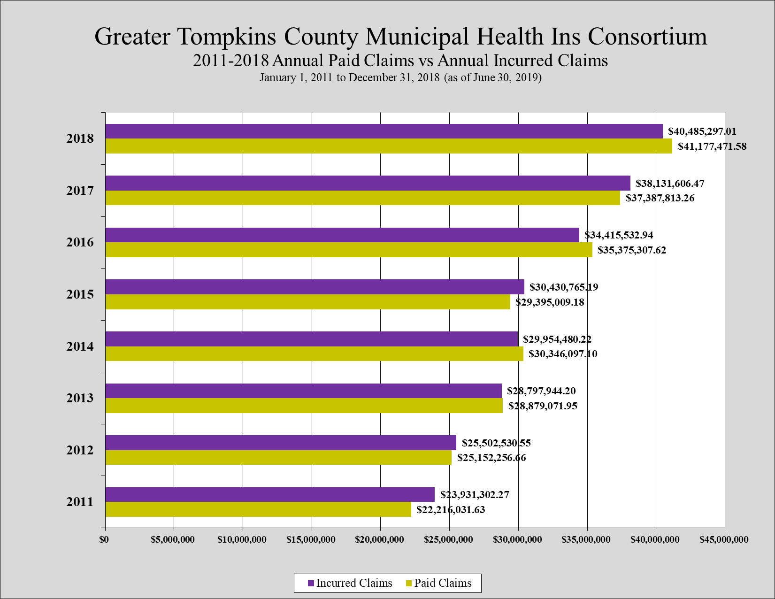

As you will note, sans the first year, the incurred and paid claims amounts are relatively the same each year. The reason for this is because in the first year you only pay the claims incurred in that year. In all other years, you are paying claims incurred in the present year and in the prior year. As a result, the NYS-DFS is basically double counting the IBNR factor in the initial year which places a difficult financial burden on the plan.

Again, as with the Surplus Account, allowing any new Article 47 Plan time to fund its IBNR Reserve would certainly make the road to developing new Article 47 Plans much easier to navigate.

***Ongoing Challenges***

Now that the GTCMHIC is ten (10) years into its operation, we have experience with the processes associated with an Article 47 Plan. To that end, we have noted a few areas where modification to either Article 47 or the NYS-DFS processes would assist Article 47 Plans in operating more efficiently and effectively.

1. NYS-DFS Reporting

The Financial Team which is associated with the GTCMHIC spends a great deal of time and effort working to provide the NYS-DFS with the financial reporting required on a quarterly and annual basis. Unfortunately, the reports the GTCMHIC is required to complete are designed for a traditional insurance company and an Article 47 Plan is far from a traditional insurance company.

Many of the pages associated with these reports are either not applicable or are time-consuming, difficult, and expensive to populate with the Consortium’s financial information as the forms are designed for traditional insurance companies. In addition, these reports format are updated frequently and often at the “eleventh-hour” resulting in wasted labor hours as we work to reformat the financial results to fit the new reporting requirement.

We suggest the NYS-DFS and the Article 47 Plans work collaboratively to develop reports and a process for submission which is much more efficient and stream-lined to ensure the financial results are received in a timely and cost-effective manner. We would also like to see these same reports used for those plans operating pursuant to Article 44 of the New York State Insurance Law as it is our opinion that these plans should have the same regulatory and funding requirements to ensure their covered members are protected.

1. Aggregate Stop-Loss Insurance Waiver

While the GTCMHIC was able to achieve a “waiver” from the NYS-DFS to forego the purchasing of aggregate stop-loss insurance for the past couple of years. It is our belief that other Article 47 Plans be offered the opportunity to waive this coverage if they have satisfied their reserving requirements for a period of time and that said decision should be left to the discretion of the Board of Directors of each Article 47 Plan. It has been our experience that this type of insurance provides very little protection and is a less than prudent use of public funds.

1. Plan Document Approval Process

The last issue we would like to raise in hopes of providing a cleaner and simpler path to Article 47 Plan development is the process associated with approving the various plans of benefit offered by the Plan. The NYS-DFS has advised the GTCMHIC that we are not able to offer any plans of benefit until such time as the insurance certificates or plan documents of those plans have been approved by the Department.

While we understand the need to have these documents approved by the Department, the process has been slow to say the least. It is our recommendation that the Department and the Article 47 Plans work collaboratively to develop a process which is much more efficient and stream-lined to ensure all insurance certificates and/or plan documents contain the proper language and are approved for distribution in a timely-manner. This would help existing Article 47 Plans and we feel it would also assist with the development of new Article 47 Plans by making their pathway that much smoother and easer to navigate.

We offer the above for your consideration as part of the review process the New York State Assembly Insurance Committee is engaged in to help foster the development of more successful Article 47 Plans, like the Greater Tompkins County Municipal Health Insurance Consortium.

We thank you for the opportunity to share our insights and we look forward to working with the New York State Governor’s Office, the New York State Legislature, and the New York State Department of Financial Services as you collectively work to facilitate the development of more Article 47 Plans across New York State. Please do not hesitate to contact us with any questions you may have or if you feel we can provide any further assistance.

Respectfully Submitted,

Judith C. Drake, Chairperson

Greater Tompkins County Municipal

Health Insurance Consortium

[www.healthconsortium.net](http://www.healthconsortium.net)