RESOLUTION NO. 031– 2022 – AUTHORIZING MEDICARE ADVANTAGE PASS- THROUGH BENEFITS- AETNA

MOVED by Mr. Salton, seconded by Mr. Fairbrother. The resolution was unanimously adopted by voice vote of members present, visibly seen members via remote Satellite locations, and locations due to extraordinary circumstances.

WHEREAS, the Greater Tompkins County Municipal Health Insurance Consortium
(GTCMHIC) is self-insured municipal cooperative health benefit plan operating pursuant to a
Certificate of Authority issued by the New York State Department of Financial Services pursuant to Article 47 of the New York State Insurance Law, and

WHEREAS, the Consortium believes that offering a Medicare Supplement Plan is
an appropriate option for Medicare eligible retirees; however, due to federal subsidies currently available to fully-insured plans the Consortium’s Medicare Supplement Plan is unable to compete with the lower costs of some Medicare Advantage Plans, and

WHEREAS, although the Consortium cannot set up a Medicare Advantage program within the fund, the Consortium can provide a convenient, pass-through option as is done with other ancillary benefits offered through the Consortium, and

WHEREAS, the Executive Committee, has determined that it is in the Consortium’s best interest to develop a relationship with Aetna to offer two Medicare Advantage Plan options to be solely administered by Aetna for medical and prescription claims.

WHEREAS, Aetna has agreed to give consideration in future years for Premium Rates to vary based on growth in enrollment numbers, now therefore be it

RESOLVED, That the Executive Committee, on behalf of the Board of Directors hereby
approves the 2023 Medicare Advantage plans, Aetna Medicare S02 ESA PPO Plan and the Aetna Medicare C04 ESA PPO Plan; Medicare Advantage pass-through option, for inclusion in the Greater Tompkins County Municipal Health Insurance Consortium’s available benefit plan menu to be effective January 1, 2023.

RESOLVED, That the Consortium, on behalf of the Consortium Board of Directors, will add an additional 2% administrative fee to the quoted Medicare Advantage plan premium to cover billing and benefit support expenses incurred by the Consortium.

RESOLVED, That any Consortium municipal member who offers the Consortium
Medicare Advantage Plan option is obligated to pay a minimum of 50% cost share of the premium rate of the Medicare Advantage plan.

RESOLVED, further, That the Chair of the Board be authorized to execute the 2023 contract on behalf of the Consortium.

* * * * * * * * * *

STATE OF NEW YORK )
GTCMHIC ) ss:
COUNTY OF TOMPKINS )

I hereby certify that the foregoing is a true and correct transcript of a resolution adopted by the Greater Tompkins County Municipal Health Insurance Consortium Executive Committee on October 5, 2022.

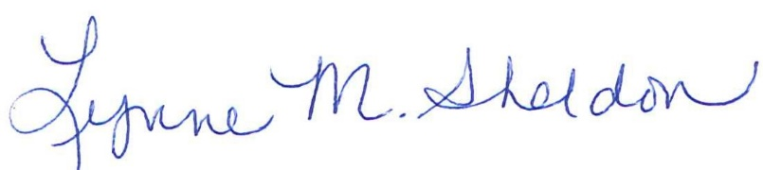

______________________________________
Lynne Sheldon, Clerk of the GTCMHIC Board

