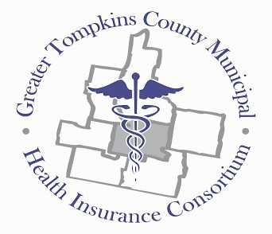
Greater Tompkins County Municipal Health Insurance Consortium
P.O. Box 7 • Ithaca, New York 14850 • (607)274-5590 Headquarters: 215 N. Tioga Street, Ithaca, NY 14850 www.healthconsortium.net consortium@tompkins-co.org

“Individually and collectively we invest in realizing high quality, affordable, dependable health insurance.”

RESOLUTION NO. 021– 2022 – ELECTION OF 2023 CONSORTIUM OFFICERS

RESOLVED, on recommendation of the Nominations and Engagement Committee, That the Board of Directors elects the following individuals to serve from January 1, 2023 through December 31, 2023 in the roles as follows:

Chairperson - Rordan Hart
Vice Chairperson – Lisa Holmes Chief Financial Officer - Steve Thayer Secretary – Peter Salton

*********

Packet Page #5

