RESOLUTION NO. - 019- 2022 - RESOLUTION OF APPRECIATION OF JUDITH (JUDY) DRAKE’S DEDICATED YEARS OF SERVICE TO THE CONSORTIUM

WHEREAS, when the Consortium was certified by the NYS Department of Financial Services it was the work of many dedicated volunteers from municipalities in Tompkins County that helped form the organization and start delivering services to its member participants in January 2011, and

WHEREAS, Judy Drake in addition to her full-time Human Resource Manager position with Town of Ithaca was supporting the Consortium as its Secretary as one of its founding members, and

WHEREAS, Judy was officially appointed as the Chair of the Board of Directors in 2014 and has been a dutiful servant leader for eight years, and

WHEREAS, Judy has been extremely involved in managing the Consortium and assisting with day-to-day operations on a regular basis, and

WHEREAS, Judy has been instrumental in creating policy, developing organizational structure, and growing the Consortium from the initial 13 members covering 2,000 municipal employees to an organization of 53 members covering 3,100 municipal employees and retirees, and

WHEREAS, Judy has not been shy with sharing her own thoughts about advancing the mission of the organization but she has also been very persistent at making sure others opinions are voiced and heard, and

WHEREAS, Judy’s work shows her attention to detail and the care and concern she has for making sure this organization continues at a high functioning level, and

WHEREAS, it is our hope that Judy will, as promised, remain involved as an active municipal participant and as the HR Manager for the organization but will also now find more time to decorate cakes, exercise at the gym, and participate in Spartan Challenges, and now therefore be it

RESOLVED, That the Board of Directors, staff, consultants, advisors, and associates, acknowledge the resignation of Judy Drake as Chair of the Board of Directors, and are appreciative for her many devoted and exemplary years of service, and

RESOLVED, further, That on this 22st day of September 2022, the Board of Directors expresses it sincere appreciation, admiration and gratitude to Judy Drake for her distinguished and dedicated service to the Greater Tompkins County Municipal Health Insurance Consortium.

* * * * * * * * *

STATE OF NEW YORK )
GTCMHIC ) ss:
COUNTY OF TOMPKINS )

I hereby certify that the foregoing is a true and correct transcript of a resolution adopted by the Greater Tompkins County Municipal Health Insurance Consortium Board of Directors on September 22, 2022.
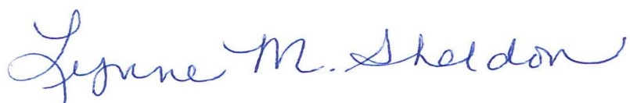

_______________________________________
Lynne M. Sheldon, Clerk of the GTCMHIC Board

