RESOLUTION NO. 018 - 2022 - Approval to Secure Contract with the Segal Company to Commence a Parallel Premium Equivalency Rating Exercise

WHEREAS, Locey & Cahill, Plan Consultants, perform a premium equivalent rating exercise annually during the budgeting process; and

WHEREAS, the Consortium desires to perform a “parallel” rating exercise or “audit” to ensure that the plans are being rated appropriately so that each plan is viable on its own or to define any vulnerabilities within the rates; and

WHEREAS, by performing an “audit” of the current premium equivalent rates it is an investment in the future success of the Consortium as members make plan enrollment shifts and new members join the Consortium; and

WHEREAS, the Consortium has had a relationship for the past few years with the Segal Company regarding analyzing and consulting on various topics, including advising on retiree plan options and an analysis of the organization prior to hiring full-time staff members, now therefore be it

RESOLVED, that the Executive Committee recommends securing a contract with the Segal Company for a parallel premium equivalent exercise “audit” as outlined in Segal’s July 27, 2022, proposal, at a rate not to exceed $75,000, and authorizes the Executive Director to provide the necessary information to commence the parallel exercise.

* * * * * * * * *

STATE OF NEW YORK )
GTCMHIC ) ss:
COUNTY OF TOMPKINS )

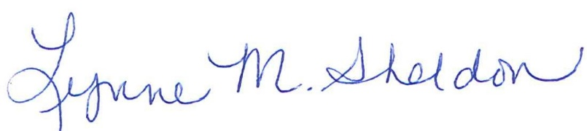
I hereby certify that the foregoing is a true and correct transcript of a resolution adopted by the Greater Tompkins County Municipal Health Insurance Consortium Executive Committee on behalf of the Board of Directors on August 3, 2022.

______________________________________
Lynne Sheldon, Clerk of the GTCMHIC Board

