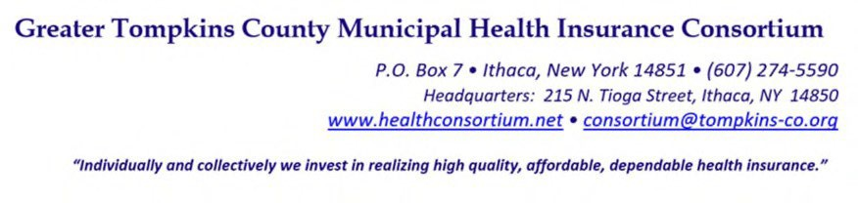
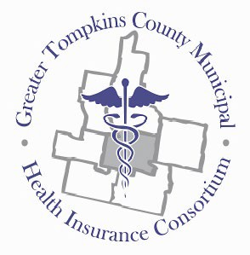

RESOLUTION NO. 015– 2022 – CREATE JOB CLASSIFICATION SYSTEM AND WAGE SCALE FOR THE GREATER TOMPKINS COUNTY MUNICIPAL HEALTH INSURANCE CONSORTIUM

WHEREAS, The Consortium created the Executive Director position through the Town of Ithaca as the Employer of Record in December 2018; and

WHEREAS, The Consortium currently has four full time positions and there are needs for additional positions being identified through Long-Range Planning process; and

WHEREAS, The Executive Director and Human Resources Manager have created a formal system for classifying positions and establishing a wage scale, which are best practices for ensuring non-discriminatory employment actions; and

WHEREAS, The Operations Committee has reviewed the proposed Job Classification Structure and the 2022 Wage Scale which will be annually modified by a Cost-of-Living adjustment through the budget process; now therefore be it

RESOLVED, on recommendation of the Operations Committee, That the Executive Committee on behalf of the Board of Directors, hereby approves the GTCMHIC Job Classification Structure and Wage Scale; and be it further and,

RESOLVED, the Wage Scale will be annually revised by a Cost-of-Living adjustment established during the budget process.

* * * * * * * *

STATE OF NEW YORK )
GTCMHIC ) ss:
COUNTY OF TOMPKINS )

I hereby certify that the foregoing is a true and correct transcript of a resolution adopted by the Greater Tompkins County Municipal Health Insurance Consortium Executive Committee on behalf of the Board of Directors on August 3, 2022.

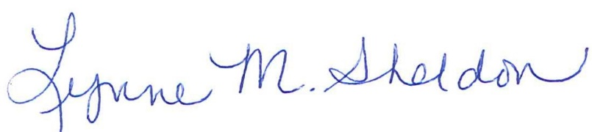

______________________________________
Lynne Sheldon, Clerk of the GTCMHIC Board

